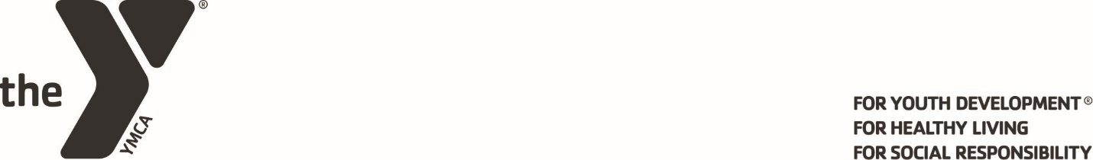
2026 Jim Lantz Memorial Scholarship Application
The Sidney-Shelby County YMCA, in collaboration with generous benefactors, established the Jim Lantz Memorial Scholarship in 2011 in memory of Jim Lantz.
Jim was a sophomore at Sidney High School. Tragically, he died in an automobile accident in November of 1986. He would have graduated in June 1989.
Jim had planned to go to medical school, and his dream was to become a doctor. He played football and basketball and he was a 4.0 student. He was also a member of the Boy Scouts and enjoyed opportunities to help others through community service.
The scholarship is a one year nonrenewable $1000 scholarship established in his memory, and applications are available at all area high schools and the local YMCA. Applicants must be a college bound high school senior and a Shelby County resident. The minimum GPA for qualification is 2.5, and after qualification GPA is not a factor.
YMCA members will receive additional consideration in determination of the winner, but YMCA membership is not a requirement. Applicants must demonstrate commitment to community service as a volunteer, with additional credit for volunteer services at the YMCA. Need will also be a factor considered in evaluation of applicants. Applicants must also demonstrate leadership qualities and exemplify Christian values.
Please note that scholarship applications are due no later than Thursday, March 12, 2026
Please be sure to include the following documents with your application:
- High School Transcript
- YMCA Program and Activity Form
- Non-Y Athletic and/or fitness activities Form
- YMCA Volunteer ActivitiesForm
- Non-YMCA Community Activities Form
- Paragraph about how you demonstrate the Y Core Values
- Three letters of recommendation
Please return completed application to:
SIDNEY-SHELBY COUNTY YMCA
ATTN: LANTZ SCHOLARSHIP
300 E. Parkwood Street
Sidney, OH 45365

Finalists will be invited to an interview in early April.

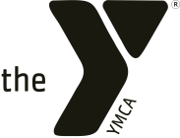
2026 Jim Lantz Memorial Scholarship Application
Name__________________________________ Home Phone_______________________
Address:________________________________ City_________________ ZIP__________
Applicant’s Email:__________________________________________________________
School: _________________________________ GPA (attach transcript) ______________
Parent(s) Name(s):_________________________ Parent Phone_____________________
- What college will you attend? ______________________________________________

2. Major field of study? _____________________________________________________
3. Are you a member of the SIDNEY-SHELBY COUNTY YMCA? Yes No
If yes, how long have you been a member? ___________

4. In what YMCA Programs and Activities have you participated?
Use the attached form to list YMCA programs/activities, and the years in which you participated.
5. Tell us about your athletic and/or your fitness activities outside the Y.
Use the attached form to list non-Y athletic and/or fitness activities in which you have participated. Be sure to list the number of years you participated and any honors or awards earned.

6. Tell us about your other (Non-YMCA) Community Activities
Use attached form to detail your community activities.

7. Attach a paragraph telling us how you demonstrate the Y core values of caring, honesty, respect, and responsibility in your life.

8. How do you plan to finance your college education?
Provide figures on an ANNUAL basis. Please give as much information as possible.
TOTAL COST OF TUITION, ROOM/BOARD FOR ONE YEAR  STUDENT’S CONTRIBUTION PER YEAR  PARENTS’ CONTRIBUTION PER YEAR  GRANTS PER YEAR  (Give source and duration of grants)  SCHOLARSHIPS PER YEAR  (Give source and duration of scholarships)  LOANS PER YEAR  TOTAL EXPECTED RESOURCES PER YEAR  GAP IN RESOURCES PER YEAR | $_______________________  $_______________________  $_______________________  $_______________________  $_______________________  $_______________________  $_______________________  $_______________________  $_______________________  $_______________________  $_______________________  $_______________________  $_______________________  $_______________________  $_______________________

8. Please list all scholarships and grants for which you have applied, their value, and how long they are for:
_________________________________________________________________
_________________________________________________________________
_________________________________________________________________
_________________________________________________________________
_________________________________________________________________

9. Please add any information that will help us understand your financial situation more clearly, including any scholarships or grants you may have already received:
_________________________________________________________________
_________________________________________________________________
_________________________________________________________________
_________________________________________________________________
_________________________________________________________________

10. How would winning this scholarship “make a difference” in your college plans?
_________________________________________________________________
_________________________________________________________________
_________________________________________________________________
_________________________________________________________________
_________________________________________________________________

11. Please attach three letters of recommendation (teachers, pastor, employer, etc.)
Please return completed applications NO LATER THAN: Thursday, March 12, 2026 to:
SIDNEY-SHELBY COUNTY YMCA
ATTN: LANTZ SCHOLARSHIP
300 E. Parkwood Street
Sidney, OH 45365

YMCA PROGRAM AND ACTIVITIES FORM
YMCA Programs/Activities | What Year(s) Did You Participate? List each year separately.

NON-Y ATHLETIC AND/OR FITNESS ACTIVITIES FORM
Sport or Fitness Activity | What Year(s) Did You Participate List each year separately. | List Any Awards or Honors

YMCA VOLUNTEER ACTIVITIES FORM - Request and then attach volunteer hours sheet from Dawn Herrick (dherrick@sidney-ymca.org)
Where Did You Volunteer? | What Year(s) Did You Volunteer? List each year separately. | Total Number of Hours Per Year

NON-YMCA COMMUNITY ACTIVITIES FORM
Where Did You Volunteer? | What Year(s) Did You Volunteer? List each year separately. | Total Number of Hours Per Year | Verifying Signature

